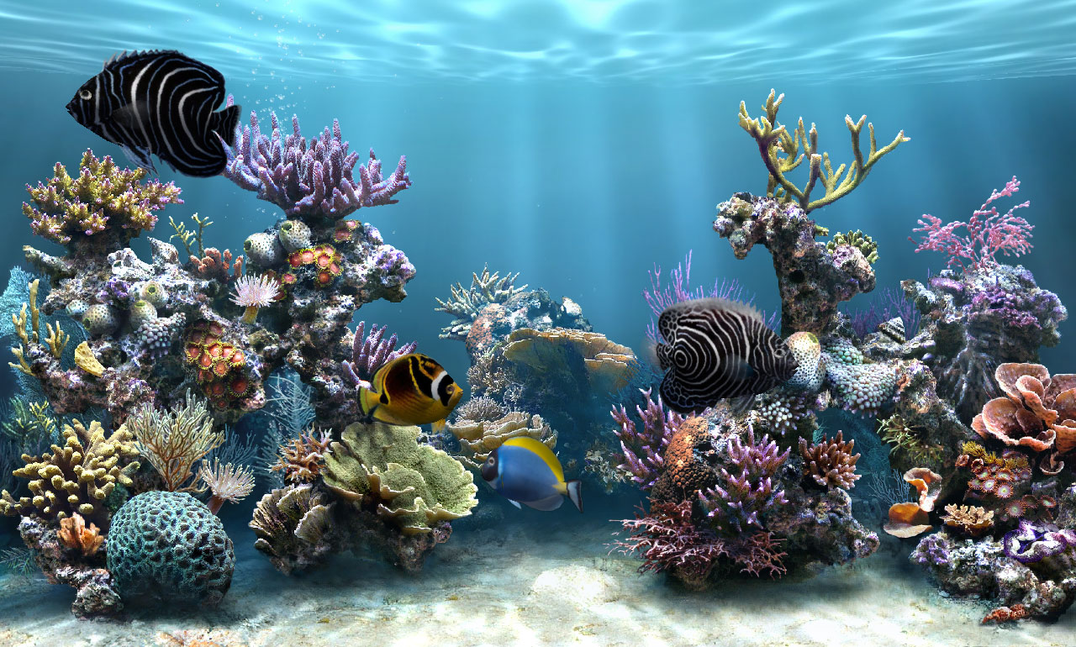

**Aquarium System**

Course Name: Linear Algebra and Vector Geometry MATH201

Spring 2023

Instructor*: Dr.ِAhmed Essam*

**Alaa Mohamed 202101529**

**Islam Safwat 202001327**

**Hayam Waleed 202100281**

**Toqa Khaled**

**Abstract**

Ensuring the Survival and Well-being of Fish in fish farms or aquariums requires the implementation of effective monitoring systems. This project focuses on the essential role of monitoring fish aquariums to maintain a suitable aquatic environment and promote fish health. The study emphasizes the regular monitoring of critical parameters, including water temperature, pH, ammonia, and dissolved oxygen. The monitoring system developed for this project is divided into two distinct parts to monitor these parameters comprehensively. The system's first part utilizes image processing features to observe and analyze fish behavior. These features, including compression, contrast adjustment, XOR image conversion, denoising, and object spotting, provide valuable insights into the behavior patterns and well-being of the fish. This was mainly done by applying the mathematical basics that illustrate basic image processing techniques based on linear algebra concepts such as matrices, vectors, Singular value decomposition (SVD), Principal component analysis (PCA), and transformations. By analyzing fish behavior, aquarium owners can gain a better understanding of their health and make informed decisions regarding their care. The second part of the system focuses on monitoring the key aquarium parameters using dedicated hardware components such as pH sensors and water temperature sensors. These sensors enable real-time monitoring and accurate measurement of the water's chemical composition and temperature. By continuously tracking these parameters, aquarium owners can identify any fluctuations or deviations from the desired levels. This information empowers them to make necessary adjustments, such as water quality treatments or temperature regulation, to create an optimal environment for the fish. Through integrating image processing features and aquarium parameter monitoring, this project offers a comprehensive solution for fish aquarium monitoring. The developed system provides aquarium owners with valuable insights into fish behavior and enables effective management of the aquatic environment. The findings of this project contribute to the enhancement of fish health and the promotion of sustainable practices in fish farms and aquariums.

**Introduction**

For monitoring the biological system in a fish aquarium, some mathematical applications were used as a way to detect changes that could affect living organisms' viability in it, examples of those changes are the PH, temperature, and abnormal behaviors that are visualized by a webcam. A full monitoring system was made using PH and DS18B20 waterproof temperature sensors connected by Nodemcu. The Nodemcu is considered as a monitoring open-source development board based on an ESP8266 microcontroller with pins on it that connect external components. Linear regression was applied by representing a plot of the linear model of PH and temperature which is used to make the data most fit with the use of a linear model coming up with identifying patterns and making predictions for the future temperature and PH values by the linear equation. The increase in temperature causes an increase in metabolic activity in organisms resulting in the accumulation of organisms' wastes, that contain ammonia, in water which increases the pH of the water. Also, another relation is that when the water has this accumulation of wastes this causes a change of movement activity that could be detected using the webcam.

The webcam visualizes the frame to be monitored which requires several adjustments and image processing. The visual input would be converted to an XOR image for easing the fish detection where the background is subtracted from the frame and considering the movable objects present, then denoising the output for clearing the unrequired pixels in the frame. In addition, object spotting was applied with its (x, y) position. As a real-life project, object spotting could help in determining the oxygen level in the aquarium. Some types of fishes have a normal level to exist in the aquarium if this level has changed to be at the top of the aquarium it could indicate a low oxygen level. Other features of image processing steps that can help to more control the aquarium using Matlab code to provide image contrast and increase the brightness or the darkness of the photo and display the histogram which represents the variation of the pixels from the different images besides the linear representation for the pixels. Another function is to enhance the image which can be useful to be used in the marketing of the aquarium company and provide higher quality images. Additional process Performing singular value decomposition. is In order to divide complex data into simpler parts, SVD, an effective mathematical tool, is utilized in many fields, including image processing. SVD is used in image processing to divide an image matrix into the matrices U, W,. V.U While W is a diagonal matrix having the singular values of the image matrix, which describe the strength of these components, U and V are orthogonal matrices that contain eigenvectors of the image matrix, which represent the direction of the main elements of the image. The image can then be represented using these matrices in a more compressed manner, which is helpful for a variety of applications, including lowering storage needs and enhancing the effectiveness of image processing algorithms. this technique in image compression allows for the size reduction of an image while maintaining visual quality. This is accomplished by only preserving the singular values and eigenvectors that represent the most crucial aspects of the image. The remaining singular values and eigenvectors can then be used to recreate the compressed image, resulting in reduced file size and quicker processing. Since some information is lost during the compression process yet the visual quality of the image is still greatly retained, this approach is known as lossy compression.

**Methods**

1. **Image Processing**

In order to code for the image processing that codes for ( **XOR image conversion -Denoising-Spotting** )

Several modules and libraries were used:

· OpenCV: OpenCV (Open Source Computer Vision Library) is a popular library for computer vision tasks. It provides various functions and algorithms for image processing, feature detection, and more.

· NumPy: NumPy is a fundamental library for scientific computing in Python. It provides support for large, multi-dimensional arrays and a collection of mathematical functions to operate on these arrays. NumPy is commonly used in conjunction with OpenCV.

· Matplotlib: Matplotlib is a plotting library in Python that allows you to create various types of plots and visualizations. It can be useful for displaying images, plotting data, and analyzing results.

The code created for this part: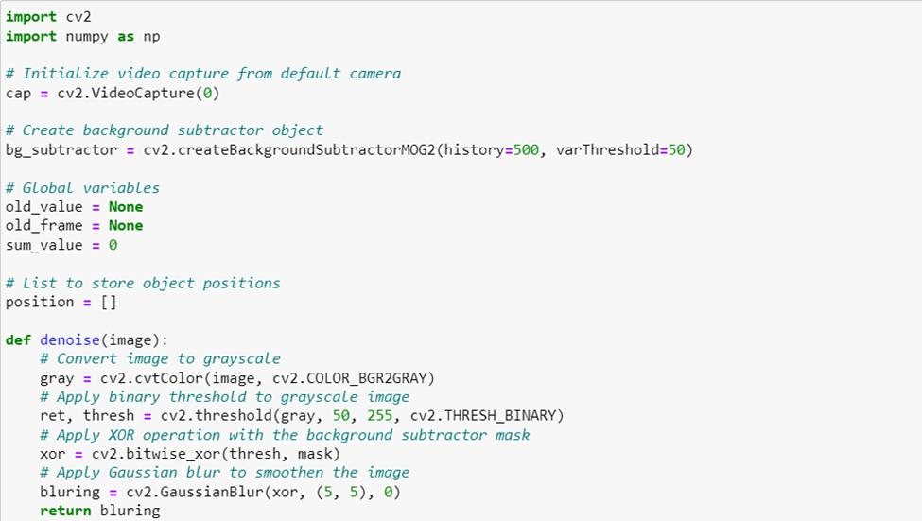

In order to code  **- contrast enhancement:**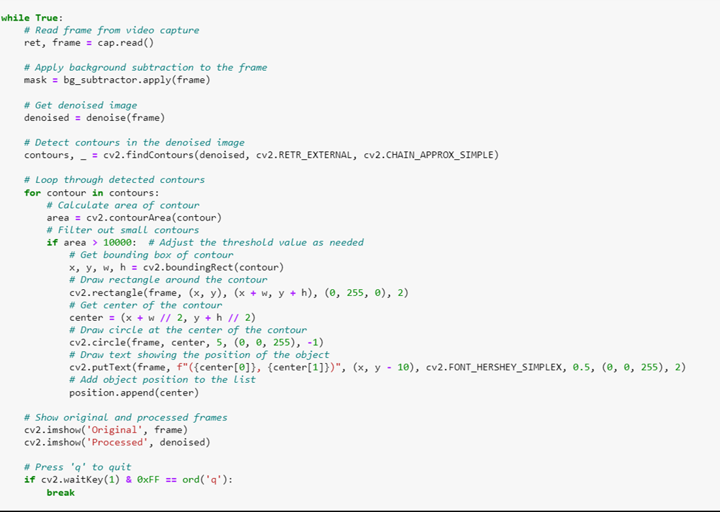

The task of image enhancement is done by modifying the image's intensity levels to increase contrast and make it look better. The first two subplots of a 2x2 grid include the original image and its histogram in order to accomplish this. The contrast of the image is then improved using histogram equalization using the "histeq" function. The third and fourth subplots, respectively, represent the enhanced image and its histogram. Overall, this part of the code helps to improve the quality of the image by enhancing its contrast, making it more visually appealing [1].

- **Compression and SVD:**

To create truncated matrices, the code applies SVD to the image and extracts the first k singular values. The compression factor k, which is set to 10, determines how many singular values are retained. The compressed image is created by multiplying the truncated matrices and is then shown alongside the original image in a separate figure window using the "imshow" function. Also, it compares the histograms of the original and compressed images to show how their pixel values differ [2].

**- Brightness and darkness of the image:**

The matrix operation is used to provide dark and bright images with the difference between the pixels for each one. This happens by controlling the intensity of the image which is represented from 0 to 255, using the matrix positive value addition to make the image bright. And matrix subtraction makes it dark and decreases the intensity.

**The code created for this part:**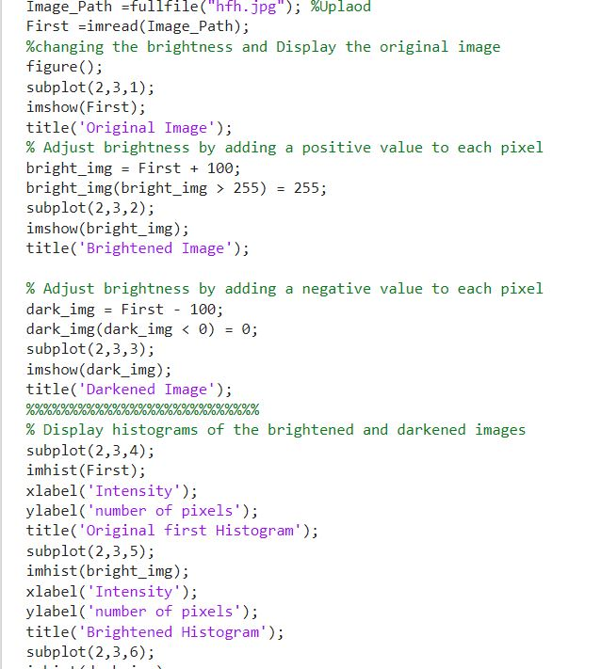

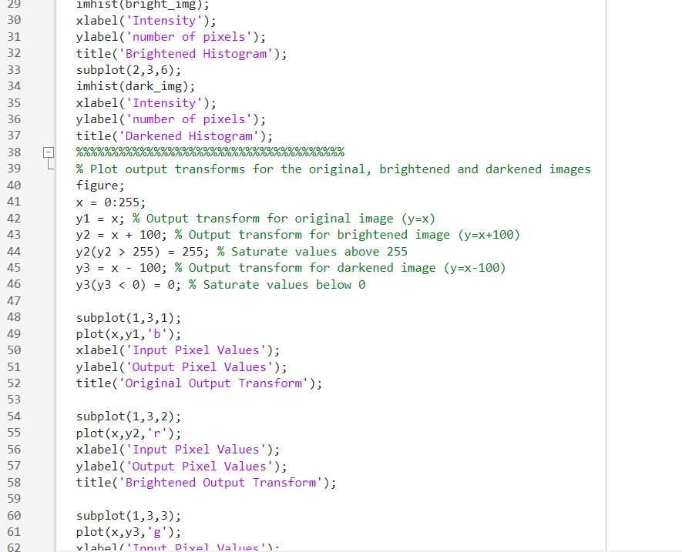

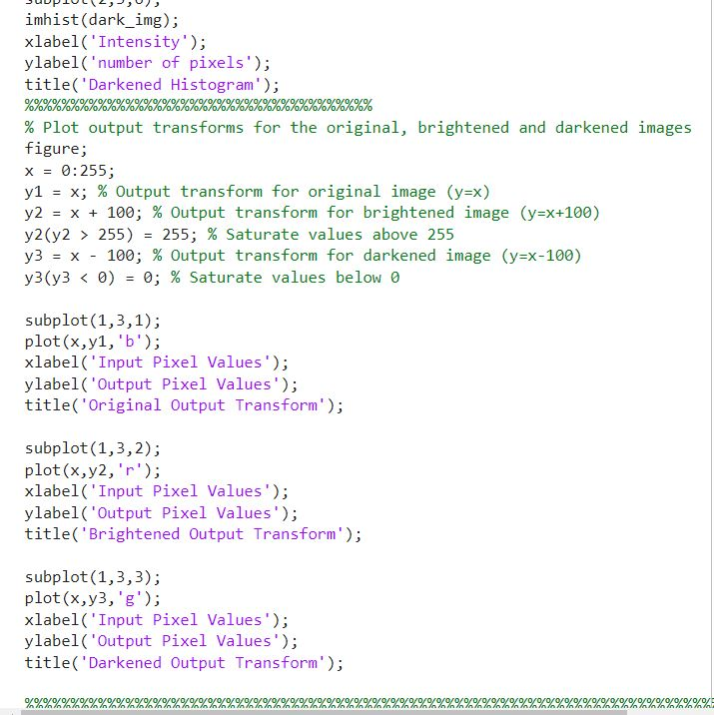

1. **Parameters monitoring**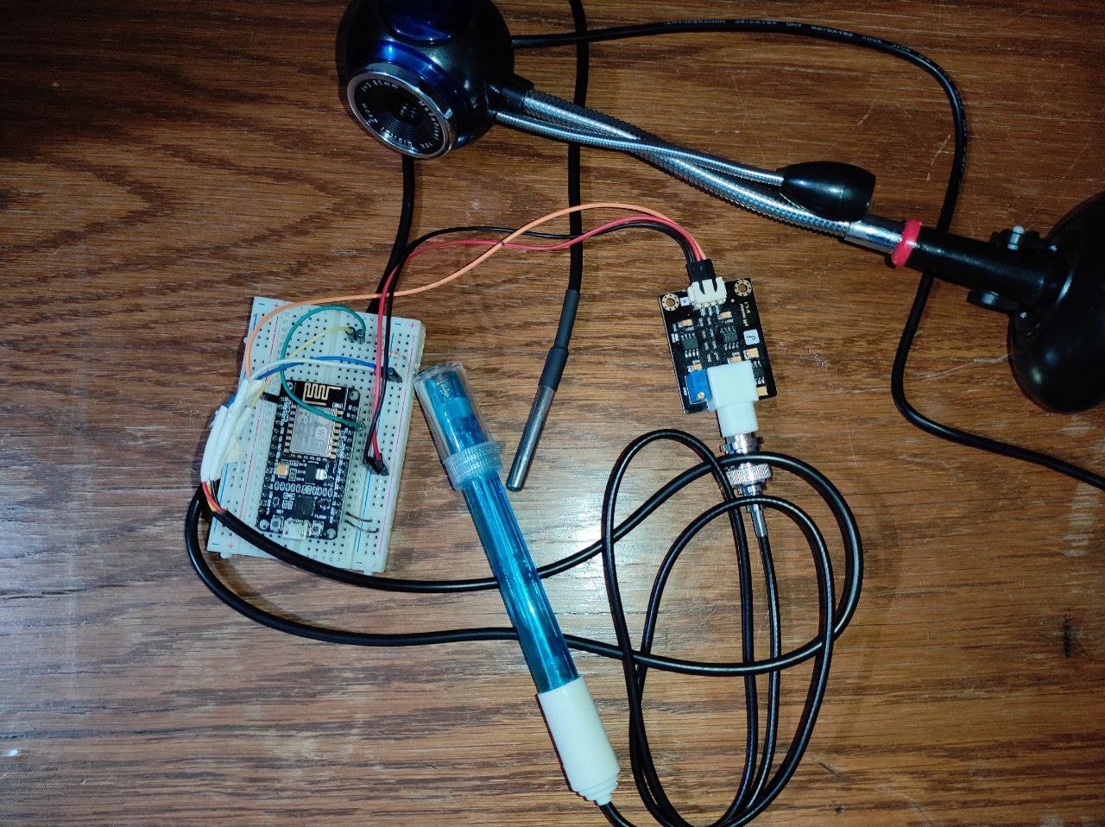

The used materials were ( PH sensor - DS18B20 waterproof temperature sensor - Node mcu - Webcam ).

In order to code for the PH and DS18B20 waterproof temperature sensor readings in a linear model, the numpy and matplotlib libraries were required for computing the mathematical functions and visualizing the output as a plot.

**The code created for this part:**

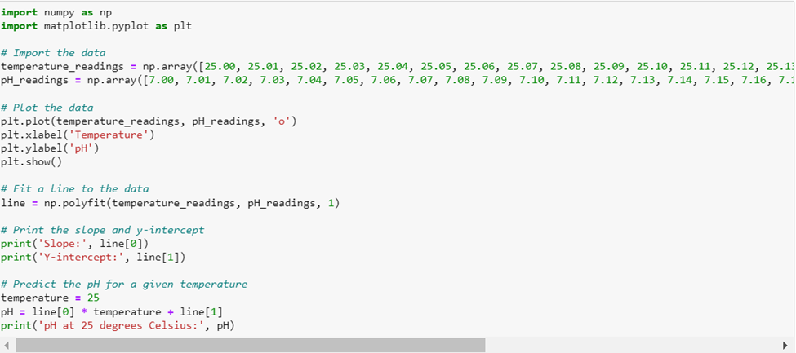

**Results**

1. **Image Processing**

Comparing the frames of the input converting to XOR image with denoising and spotting the object before interpreting (x,y) position.

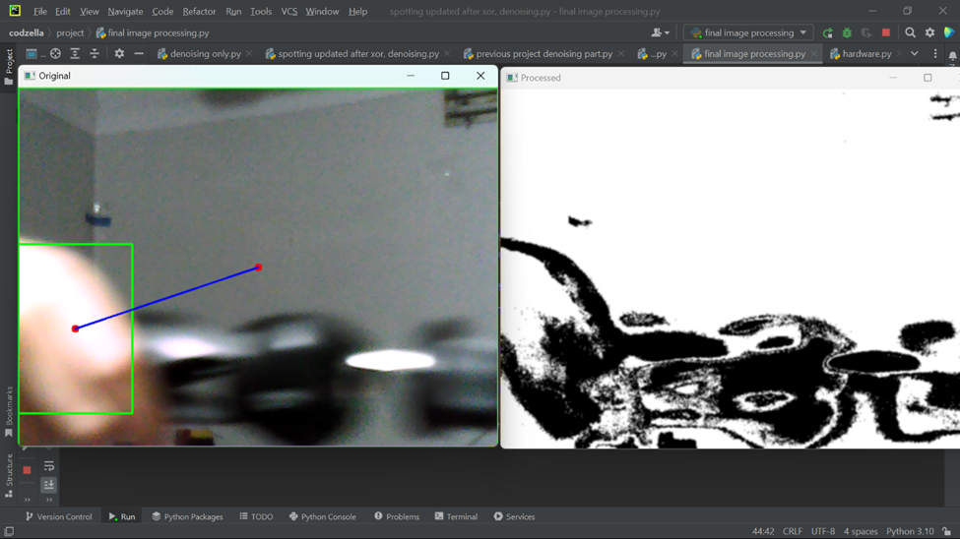

Comparing the frames of the input converting to XOR image with denoising and spotting the object after interpreting (x,y) position

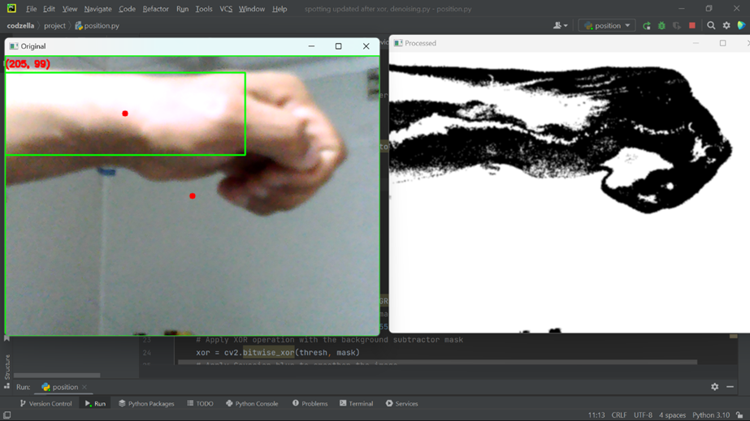

Slope: 0.99

Y-intercept: -17.99

pH at 25 degrees Celsius: 7.000000000000014

the linear model equation is Y = 0.99X -17.99

**Part B:**

Image brightness and darkness with histogram represent the pixels and linear representation for the relation between pixels after and before the transformation for each image.

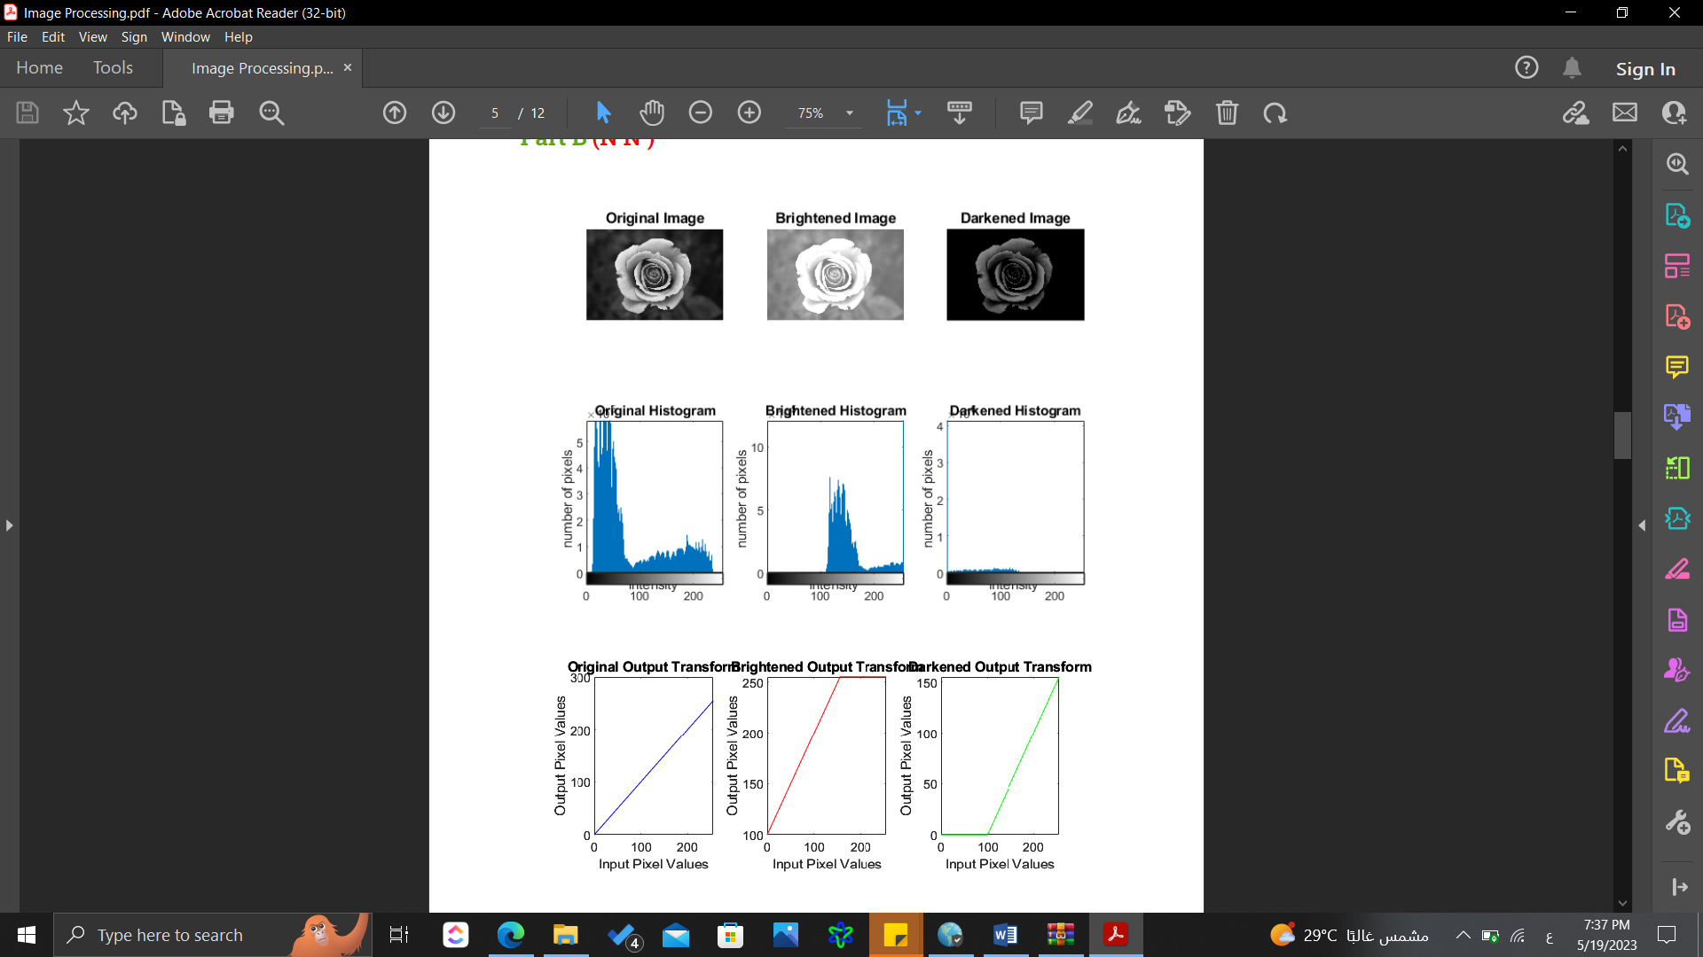

The image enhancement was done by manipulating the contrast as shown in figure(1), and the comparison between the original and compressed images is shown in figure(2).

**fig(1): comparison between original and enhanced image fig(2): comparison between original and compressed image**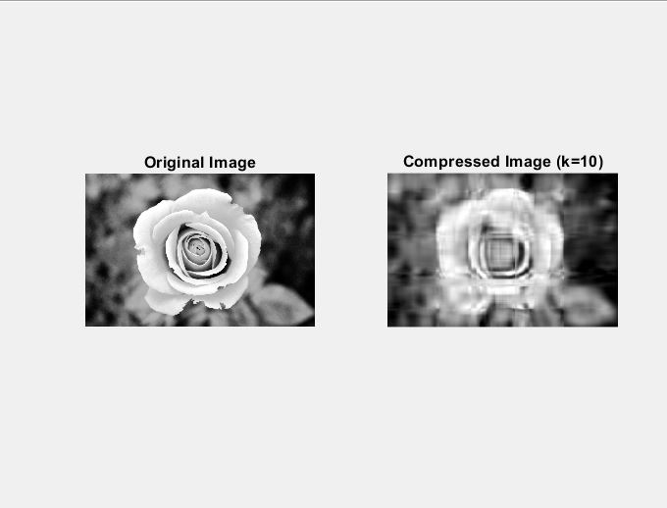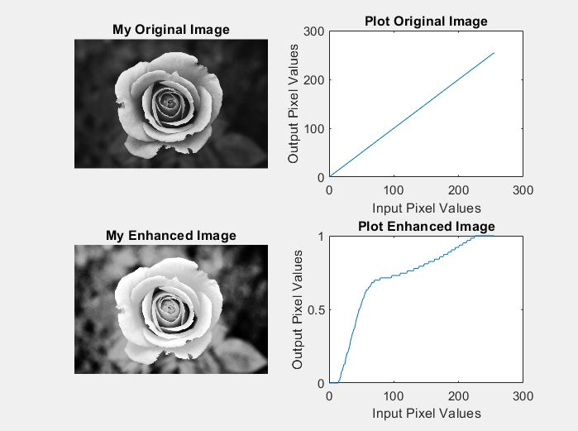

1. **Parameters monitoring**

The plot of PH and Temperature sensor readings:

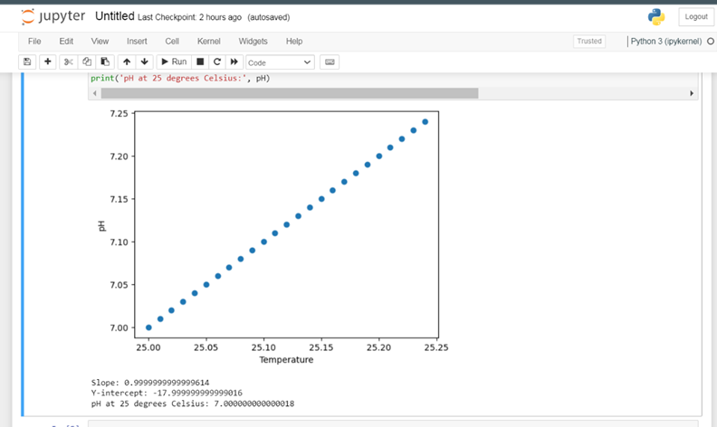

**Conclusion**

In conclusion, this project shows how mathematics could be used in monitoring a biological system, specifically an aquarium with the aid of advanced technology, and image processing.

With benefits from different parameters that cause changes to Marine creatures such as temperature ,pH and these creatures' movement in water. Using pH and temperature sensors to collect data about the state of water and webcam to record motion of the creatures in water . By analyzing sensors data, applying linear regression, and using webcam records. These findings provide us with the chance to take control of the ecosystem's vitality. The monitoring process is improved by image processing methods' assistance in visualizing,enhancing and compressing pictures . Overall, this research project demonstrates how different tools and approaches may be used to produce a thorough and effective monitoring system for biological systems.further approaches ,would be implying those collected data in a large scale and come up with a mathematical relations upon linking between those different parameters and add others if happen to relate with them . to ensure the vitality of the aquatic system in a specific region to achieve a long-term sustainability of aquatic ecosystems .

**References:**

[1] V7 Labs. (n.d.). Image Processing Guide. Retrieved from https://www.v7labs.com/blog/image-processing-guide

[2] Compton, A. (2020). Citations: The Basics. LaGrange College.

Retrieved from https://www.lagrange.edu/academics/undergraduate/undergraduate-research/citations/18-Citations2020.Compton.pdf

[3]Components101. “NodeMCU ESP8266 Pinout, Specifications, Features & Datasheet.” *Components101.com*, 22 Apr. 2020, components101.com/development-boards/nodemcu-esp8266-pinout-features-and-datasheet.

[4]Frost, Jim. “Making Predictions with Regression Analysis - Statistics by Jim.” *Statistics by Jim*, 4 Maalgone. “Aquarium Water Parameters for a Balanced Fish Tank.” *Algone*, 6 May 2011

[5]